Social media kit
UN 2023 Water Conference
22-24 March 2023, New York, UNHQ

Hashtag: #WaterAction
Secondary hashtags: #GlobalGoals, #SDGLive (SDG Media Zone only)
Handles: @UN (Twitter), @unitednations (Facebook&Instagram) @United Nations(LinkedIn)
@GlobalGoalsUN (Twitter), @Sustainabel Development Goals (Facebook)

Related websites:
- Conference website: https://sdgs.un.org/conferences/water2023 (Short link: https://bit.ly/Water2023 )
- Goal 6 webpage: https://www.un.org/sustainabledevelopment/water-and-sanitation/ (Short link: bit.ly/sdggoal6)
- WaterAction page: https://www.un.org/sustainabledevelopment/un-2023-water-conference-engagement-5-water-actions-you-can-take/
- Lazy person’s guide on #WaterAction https://www.un.org/sustainabledevelopment/the-lazy-persons-guide-to-saving-water/
- Webcast: webtv.un.org

Top conference social media moments (continue to be updated):
- 21 March: Launch of the Water Development Report at UN Headquarters
- 22 March: World Water Day
- 22 March: SDG Media Zone
- 23 March: World Meteorological Day
- 22-24 March: Daily Water Conference press briefings, webtv.un.org.

Social media kit materials

- All social media materials are available at: https://trello.com/b/onF4SVco/un-2023-water-conference
- New materials will be added to this board in the lead-up to and every day of the conference.

Suggested messages (continue to be updated)

Thematic focuses | Suggested messages | Asset
Countdown & generic messages | Water is life.  Water connects us.  Water is possibility!  JOIN the discussion in the upcoming UN 2023 Water Conference and take #WaterAction.  ➡️ https://bit.ly/Water2023  [CARD]  OR  [CARD/GIF] | 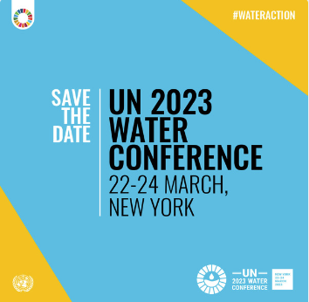  Download  https://trello.com/b/onF4SVco/un-2023-water-conference
Quote card | SAVE THE DATE  💧The UN 2023 Water Conference will bring together all stakeholders to take bold #WaterAction & address the challenges surrounding water.  🗓️ 22-24 March  ➡️ https://bit.ly/Water2023  #WaterAction #GlobalGoals | 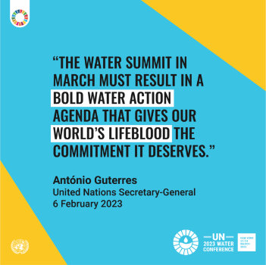  Download  https://trello.com/b/onF4SVco/un-2023-water-conference
Access to water – human right | Clean water is a human right.  Around 2 billion people still lack safe drinking water.  Get ideas on what #WaterAction you can take.  ➡️https://bit.ly/5WaterActions  [CARD] | 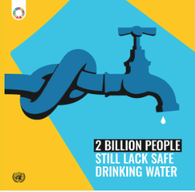  Download  https://trello.com/c/ltkytZNw  OR  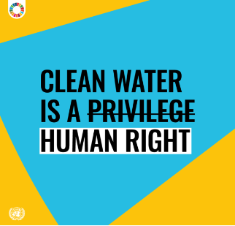  OR  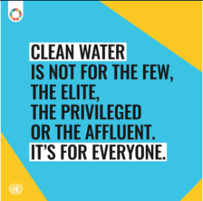  Download  https://trello.com/b/onF4SVco/un-2023-water-conference
Water and sanitation | More people have access to mobile phones than toilets and sanitation.  But access to safely-managed sanitation is crucial for healthy lives.  The UN 2023 Water Conference will be an opportunity to scale up the efforts to ensure access to sanitation for all. #WaterAction  ➡️ https://bit.ly/Water2023  [CARD] | 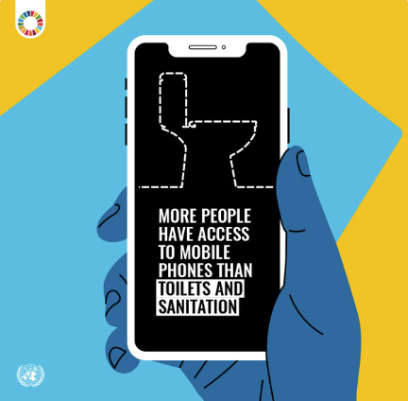  Download  https://trello.com/b/onF4SVco/un-2023-water-conference
Water -Gender | In many areas affected by water stress, women & girls have the responsibility of fetching water  Access to clean water should NOT be a burden for women & girls  Embedding gender equity into policy at will be crucial to achieving water & sanitation for all  #WaterAction  https://bit.ly/Water2023  [CARD] | 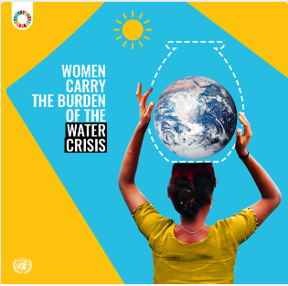  Download  https://trello.com/b/onF4SVco/un-2023-water-conference
Water- Gender | Water💧 or School🏫?  NO GIRL SHOULD HAVE TO CHOOSE.  Water collection can take time away from girls’ education and sometimes even prevent their attending school altogether.  We must take #WaterAction now to ensure a water-secure future for ALL.  https://bit.ly/Water2023 | 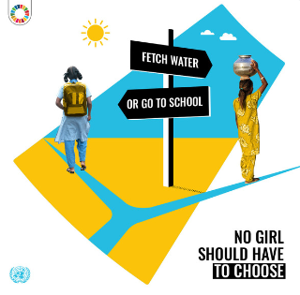  https://trello.com/b/onF4SVco/un-2023-water-conference
Water Stress | Water scarcity causes a ripple effect across societies:  🧳Displacement  🍞Food scarcity  🪫Energy shortages  🏫Missed school day  🕊️Conflict  …  We need innovative solutions and #WaterAction to keep water flowing.  https://bit.ly/Water2023 | 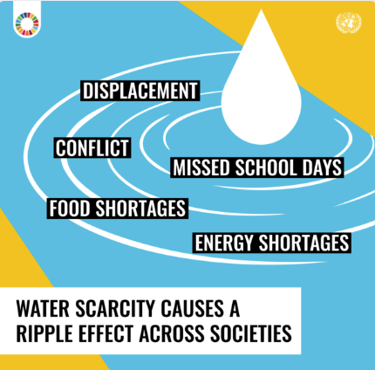  https://trello.com/b/onF4SVco/un-2023-water-conference
Water for Climate | Climate change is happening now.  Water is part of the solution.  🚿Take short shower  🪴Avoid over-watering plants  🥘Throw away less food  🌞switch to renewable powered water system  Addressing the climate & water crisis is possible if we #ActNow. https://bit.ly/3GT7zDb  [CARD] | 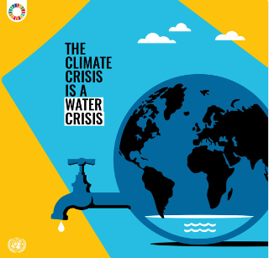  Download  https://trello.com/b/onF4SVco/un-2023-water-conference
Water Action | We need action to ensure everyone has access to clean and safe water supplies.  Everyone can be part of the solution:  🚿Take shorter showers  🚰Don’t let the tap run  🍅Buy local, seasonal food  Share your #WaterAction  ➡️ https://bit.ly/5WaterActions  [CARD] | 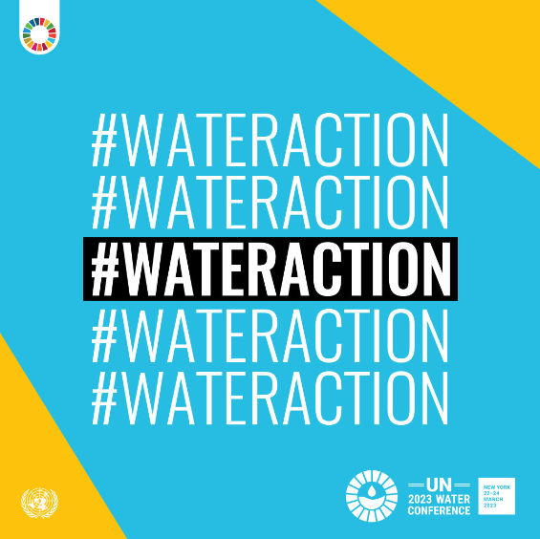  https://trello.com/b/onF4SVco/un-2023-water-conference

