

|  |  |  |
| --- | --- | --- |
|  | | |
|  | | |
| Explanada – Ingreso a la Conferencia | | |
|  |  | |
|  | |  |
|  | | |

|  |  |
| --- | --- |
| Corredor con ODS en la planta baja | |
|  |  |



**Ceremonia de Apertura - Fotos desde Sala 2**

|  |
| --- |
|  |
|  |

***Partnerships and Cooperation for Water***

Lanzamiento del documento anual de UNWater-UNESCO

|  |  |
| --- | --- |
|  |  |
|  | L  ink  https://unesdoc.unesco.org/ark:/48223/pf0000384655 |

***Transboundary Cooperation and Scince for the Sustainable Management of Amazons Waters***

|  |  |
| --- | --- |
|  |  |

***NDC Enhancement through a water nexus approach***

|  |  |
| --- | --- |
|  |  |

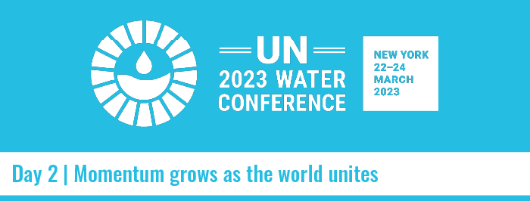

***Water and Agricultural for Climate in Latin America and the Caribbean***

|  |  |
| --- | --- |
|  |  |

***Accelerating sustainable development through water innovation and solution***

|  |  |
| --- | --- |
|  |  |

***Sustainable Climate Action for Water Crisis***

|  |  |
| --- | --- |
|  |  |

***Supporting gender equality in the Water Action Agenda with Global multi-stakeholder effort***

|  |  |
| --- | --- |
|  |  |

***Interactive Dialogue – Water for Cooperation Transboundary and International Water Cooperation Cross Sectorial Cooperation,   
including Scientific Cooperation and Water Across the 2030 Agenda***

|  |  |
| --- | --- |
|  | Participación desde el exterior |
| Sala 4 donde se realizaban los Diálogos | |
|  | |



***Tercer dia***

***Groundwater: an invisible cross-sectoral fundament for implementation of the   
Water Action Agenda***

|  |  |
| --- | --- |
|  |  |

***Science-Based Global Water Assessment***

|  |  |
| --- | --- |
|  |  |

***Water and peace with no boundaries***

|  |  |
| --- | --- |
|  |  |

***Evento de Clausura***

|  |  |
| --- | --- |
|  | |
|  |  |
|  |  |

***IARH Interactuando***

|  |  |  |
| --- | --- | --- |
|  |  | |
| ***Miguel Doria  PHI Unesco*** | ***Gabriela Calderón Universidad de Mar del Plata*** | |
|  | |  |
| ***Sam Fernald – New Mexico State University***  ***Sharone Megdal - The University of Arizona*** *(derecha)* | | ***Damian Indig***  ***CapNet*** |