
'

Virtual Meeting Space

http://portal.worldwaterforum5.org

User Guide

Table of contents

1. Introduction 2
1.1. What is the Virtual Meeting Space? 2
1.2. How do I log onto the VMS? 2
1.3. What will I see when I first log on? 2
2. How can I get informed about the Forum? 3
2.1 Browsing and using the search engine 3
2.2 RSS feeds 3
2.3 Alerts 4
3. How can I take part in the processes I’m interested in? 4
3.1 How can I contribute to the different workspaces? 4
3.2 How can I work within a workspace? 5
3.3 How can I contribute to the production of a document within a workspace? 6
4. How can I contribute to the Forum? 7
4.1 How can I contribute to the session development process? 7
4.2 How can I apply for the Water Prizes? 7
5. How can I register for the Forum? 7
6. How can I use the VMS for networking opportunities? 8
7. What else can I do through the VMS? 8
8. Who should I contact if I have any questions? 8
Annex 1 User roles 9

Introduction

What is the Virtual Meeting Space?

The 5th World Water Forum’s Virtual Meeting Space (VMS) is an interactive password-protected portal, using Microsoft SharePoint technology, which will virtually bring together those interested in identifying solutions to the most crucial water-related issues in the world today. It will be a central place for the preparation of the 5th World Water Forum’s thematic, regional, political and major group processes, as well as the sessions and many other components. By facilitating the contribution to the Forum of thousands of individuals and organizations, through a participatory and consultative approach, it will enhance the communication, exchange, networking and collaboration within the water community as well as allowing water experts to discuss with professionals from other disciplines. This user guide will explain how you can use the VMS to make a difference to the 5th World Water Forum.

How do I log onto the VMS?

The VMS is accessible through http://portal.worldwaterforum5.org, through any web browser and from any computer, although it is designed to optimally interact with Microsoft Internet Explorer. Entering the user name and password that have been sent to you will take you to the VMS home page (see figure 1). Please note that both your username and password are case-sensitive. When you first log into the VMS, we recommend that you personalize your password by clicking on “Welcome (your name)”, in the menu at the very top of the screen, then selecting “Change Password”. If you have any problem with or have forgotten your password, please click on “Forgot your password” from the login page.

What will I see when I first log on?

The VMS home page (see figure 1) is the starting point for your participation in the Forum. From the left-hand menu of the page (1) you can access the various workspaces. The same options are repeated for your convenience in the top menu bar (2), and remain visible throughout the VMS. In the centre of the home page (3), you can view the latest general news related to the Forum, the Forum Document Library, some useful web links and the Water Events Calendar. On the top-right corner of the page (4), you can search the VMS for useful information and look for other users. Finally, on the right-hand side of the home page (5), you will find the four main means of organizing your participation in the Forum, described below.

Figure 1 The VMS home page
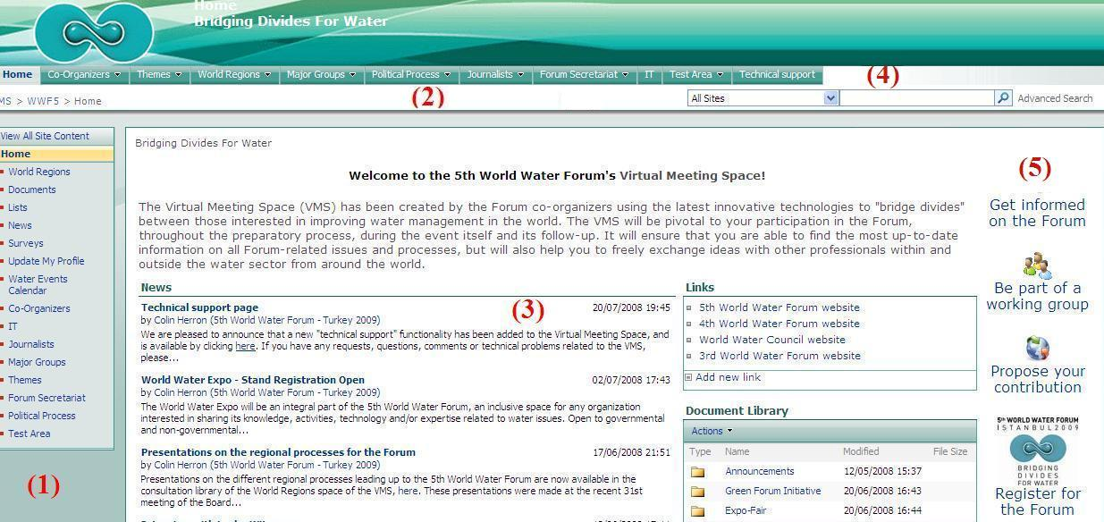

The four main means of organizing your participation (5) in the 5th World Water Forum are the following:

- Get informed on the Forum, by subscribing to RSS feeds and alerts to keep up-to-date on the progress of the themes, topics, regions, major groups and political processes;
- Be a part of the Forum, by adding yourself to the workgroups and processes you would like to take part in;
- Contribute to the Forum, through the session development process, the Water Prizes, and many others mechanisms; and
- Register for the Forum, book your hotel, airport transfer and tours, and plan your stay in Istanbul.

How can I get informed about the Forum?

Browsing and using the search engine

The Virtual Meeting Space is a mine of useful information on the various components of the Forum, which you are kindly invited to browse. To see what has already been achieved, please feel free to click on the workspaces you are interested in, or alternatively use the search engine to find useful documents (see figure 2). For a simple search, simply type in the word you are looking for and click on the magnifying glass. You may also carry out an advanced search, to find more specific documents or to search for other system users, by clicking on the corresponding icon.

Figure 2 VMS search engine

Additionally, in order to be automatically informed as soon as there are any new developments in the areas you are most interested in, please click on the “get informed” icon on the VMS home page. Through this option, you can select to be informed on the progress of any of the themes, topics, regions, major groups and/or political processes, either through RSS feeds or e-mail alerts (see figure 3). These two options are explained in greater detail below.

Figure 3 RSS feeds and alerts page
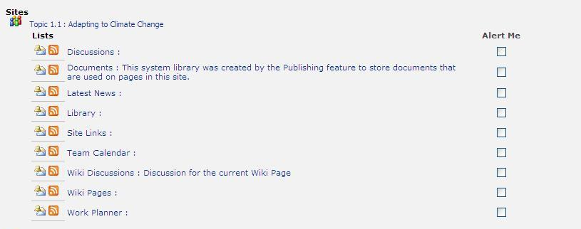

RSS feeds

By clicking on the corresponding icon (), you can subscribe to RSS feeds for the issues you are most interested in. RSS (Rich Site Summary) feeds are used to deliver news updates to an RSS reader, so that all of the latest news on the various issues that interest you are available whenever you decide to view them. It helps you to save time, since you may have various sources of information in one place, instead of having to search for them in different sites. A number of RSS readers are available free of charge over the Internet. Click here for a list of some of the most common. For the VMS, the RSS feeds apply only to the “latest news” section.

Alerts

Clicking on the “alert me” option () for any component of a workgroup activates the corresponding e-mail alert. Alerts allow you to be automatically informed by e-mail whenever there is a new development in the area you are interested in. Each e-mail alert that is sent to you contains the text of the new item and a link to view the complete item in the VMS. For the VMS, you may subscribe to alerts for the library, discussions or latest news sections of each workspace. When subscribing to an alert, you may choose if you would like to receive these alerts as soon as a change is made, daily or weekly.

Please note that you may also subscribe to the RSS feeds and alerts from within any workspace of which you are a member. To do so, simply click on the “Actions” option in the corresponding space (see figure 4).

Figure 4 Manual subscription to alerts and/or RSS feeds
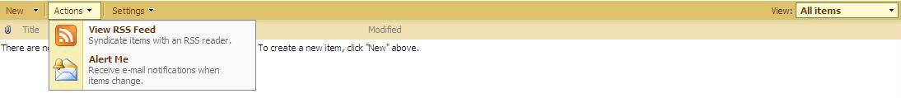

How can I take part in the processes I’m interested in?

How can I contribute to the different workspaces?

In the workspaces of the themes, topics, regions, major groups and political processes, as well as reading the latest news and articles, any VMS user may also participate in the discussion forums and surveys, and whatever other means the workgroup has developed for public consultation. However, if you are interested in playing a more active role in a workgroup, please click on “be part of a working group” on the VMS home page, which will take you to the workgroup request form (see figure 5). Selecting the workgroup(s) you are interested in will automatically add you to that group’s consultative group (please refer to annex 1 for a definition of user roles).

Figure 5 Workgroup request form
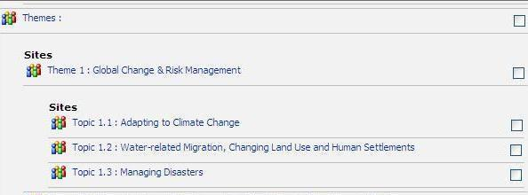

Being a member of a workgroup’s consultative group will allow you to view and comment on the documents produced by the topic coordinators and consortia, allowing you to bring your experience and perspective to the documents produced by the workgroup. If you actively contribute to the issue at hand, the coordinator of that group also has the ability to make you a member of the consortium or even a co-coordinator.

How can I work within a workspace?

When you enter any workspace, you will see a number of functionalities in the centre of the screen, which are repeated in the left-hand menu (see figure 6). These functionalities are either “private” for the working and consultative groups, or “public”, meaning that all VMS users can view the information in question. You will only see the functionalities that your user rights allow you to view. Within each workspace, the public functionalities are the following:
  - Latest News: facilitates the sharing of the latest information on the issue at hand;
  - Survey: allows workgroups to canvass the opinion of others on any given topic;
  - Water Events Calendar: a list of all events in the world of water. You may view a filtered list of the events related to each topic, theme, region or major group by clicking on “related events” from the central screen of each space’s home page;
  - Discussion: allows the workgroup to exchange views on any given issue;
  - Library: to share any relevant document or report, either produced by the workgroup or by third parties;
  - Wiki Pages: can be used to develop common texts within workgroups;
  - Links: a list of useful web links related to the issue.

Each workgroup’s private functionalities are as follows:
  - Document Production: allows workgroups to produce, share and improve their joint documents, keeping track of versions and storing them in a single place;
  - Team Calendar: a list of the various milestones on the road to the Forum, including meetings and teleconferences;
  - Team Work Planner: a Gantt planner to assign responsibility for and follow up on the workgroup’s various tasks.

Figure 6 Workspace home page
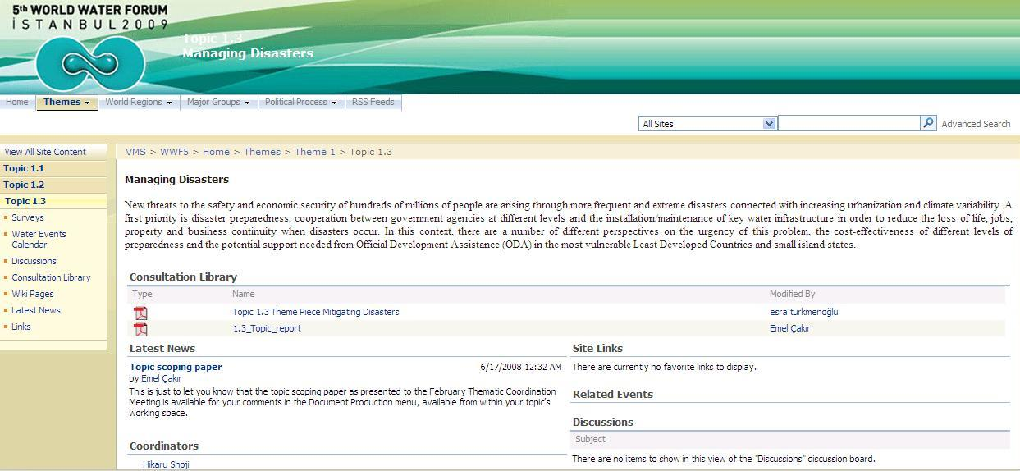

Within each of these functionalities, depending on your user status within that workgroup, you may carry out the following actions:

- Upload a new item, by clicking on “upload” in the top menu;
- Consult an existing item, by simply clicking directly on the name of the item in question;
- Create a new folder to group similar information, by clicking on “new” in the top menu;
- Subscribe to an alert to be informed by e-mail of any changes made to the space, by clicking on the “actions” menu and selecting “alert me”;
- You may also have access to a number of other options, including viewing the version history, creating advanced workflows, managing permissions, deleting documents and document check out, by clicking on the down arrow next to the item, shown in figure 7.

Please note that all work that goes on through the VMS should be in English, the official language of the Forum.

How can I contribute to the production of a document within a workspace?

If you would like to make any changes to the document, you should first check it out by clicking on the down arrow next to that document (see figure 7) and selecting “check out”. Checking out a document blocks it so that no other user can modify the document at the same time, and therefore avoids the possibility of there being several different versions. Other users will still be able to view the saved version of the file, but will not be able to save any changes they might make until you check it back in. They will also be able to see who has checked it out. You should not keep a file checked out for more than a couple of days at most, to ensure that others can also contribute to the document.

Figure 7 Document options
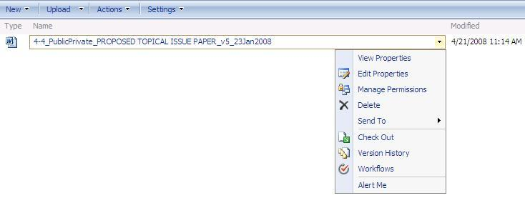

Once your document is checked out, a diagonal arrow will appear in the bottom right-hand corner of the file icon. To then edit the document, you should do the following:

- Open the file, by clicking on the file name again, and saving it to your own computer.
- It is advisable to make any changes in the “track changes” mode of your document editing tool, to ensure that other users can easily identify them.
- Once you have finished editing the document, you should close it and save the changes.
- Back in the workspace in the VMS, click on “upload” (in the top menu) to upload your new version. This will automatically replace the previous version of the document, and check it back in. All users that have activated an “alert” or an RSS feed for that section of the workspace will be informed that a new version has been posted.

At any time you may review the document’s version history, by clicking on “version history” in the “other options” menu, shown in figure 7. From this page, you may view the changes that have been made to the document, and if you have the appropriate rights, restore a previous version of the document, by clicking on the arrow to the right of the version you would like to restore.

When a document is ready for review by a larger group, you may place it in the Library section, to invite more contributions. In this Library, all VMS users may read the file, and may comment on it through a discussion forum, although they cannot make changes directly to the document.

How can I contribute to the Forum?

There are many ways of contributing to the Forum, all of which will be facilitated by the Virtual Meeting Space. These means of contributing will be gradually developed as the Forum draws closer, but currently include the session development process and the Water Prizes.

How can I contribute to the session development process?

Through the VMS you are invited to take part in the ongoing session development process. The Forum’s 100 sessions will be centred around key questions that have been identified for each topic, and for which we are seeking your action-oriented solutions. Each session will involve different stakeholders who will discuss the issues from their perspective. Complete session proposals and scientific exposés will not be solicited, but rather expressions of interest to contribute solutions for particular questions will be welcomed. It is hoped that this structure will result in better overall focus, quality and interaction.

You may propose your contribution by filling in the ‘contribution to sessions’ form, available by clicking on the “propose your contribution” icon on the VMS home page, also available within each topic space. All proposed contributions will be considered for incorporation into the session development process. Session conveners and contributors will work together to finalise the structure and contents of each session by the end of 2008. The call for contributions closes on September 30th, 2008.

How can I apply for the Water Prizes?

By clicking on the “contribution” icon, you may send your application for the Water Prizes to be organized at the 5th World Water Forum. The application forms will be gradually phased in. Initially the application forms for the Kyoto World Water Grand Prize and the Turkish Republic Prize Minister’s Water Prize are available. The deadline for applications for the Kyoto Prize is October 31st, 2008 and for the Turkish Prime Minister’s Prize it is December 30th, 2008.

How can I register for the Forum?

By clicking on the “registration” tab on the VMS home page, you will be taken directly to the Forum registration site. Your user information will be sent automatically from the VMS to the registration site, meaning that you will not have to re-enter your personal details. Through the registration site, you may do the following:

- Register for the Forum, for one day, three days or the whole week;
- Register groups of up to 15 individuals;
- Book your hotel from a wide selection;
- Discover the beauty of Istanbul and Turkey by booking your tourist and social activities, before, during or after the Forum;
- Reserve your transfer from the airport to the hotel and back;
- Make your payment by Visa, Mastercard or bank transfer;
- Make any special requests to facilitate your participation and stay.

Please note that the registration site is managed by the 5th World Water Forum’s Professional Conference Organizers (PCO), Perl PCO, who will be pleased to answer any questions you may have in order to facilitate your stay in Istanbul.

It is worth mentioning that a number of discounts are being offered in the registration fees, including a 20% discount for all participants who register before December 31st, 2008, and further discounts for young people and participants from developing and the least developed countries. Each active member of the World Water Council will also receive a 20% discount for five of its representatives. For more information on the registration process, please visit the 5th World Water Forum website.

How can I use the VMS for networking opportunities?

The first step to let other users know about you is to update your profile, by clicking on “Update My Profile” on the left-hand menu of the VMS home page (see figure 8). Once you have completed the profile form, you will be taken to “My Site”, your personal home page within the VMS that has shortcuts to all of your workgroups and other information that you are interested in, including your documents, links and colleagues. Each user that has clicked on his or her “My Profile” has a personal home page that you can search, to find individuals or organizations that are interested in and knowledgeable about similar activities. This function will eventually allow the VMS to become the “Who’s Who Of Water”, thus greatly enhancing the networking opportunities (and “bridging divides”) for the water sector.

Figure 8 Update My Profile
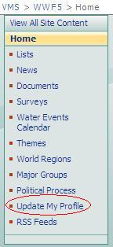

What else can I do through the VMS?

A large number of other functionalities have either already been developed or will be in the coming weeks and months. Just to cite a few examples:

- The Water Events Calendar is a list of all events related to water, that may be added to by any VMS user. This information will also be placed on the events page of the World Water Council’s website. Take this opportunity to let others know about your event!
- The Document Library allows useful reference documents on the 5th World Water Forum to be shared with any interested party.
- The Forum Knowledge Base (coming soon) will contain useful reference material from the previous World Water Fora, to ensure that the 5th Forum builds upon the previous editions.

If you have any further suggestions for improvement, please let us know!

Who should I contact if I have any questions?

By clicking on the “Technical Support” tab in the top menu bar, you may either make a request to the system administrators, or view the existing discussion fora to see if your question has been asked before. Any additional questions or requests for information about the Virtual Meeting Space may be directed to Colin Herron at colin.anthony.herron@gmail.com.

Annex 1 User roles

Within each user space, by default there are five main groups of user roles, with differing rights accorded to each. These rights can be modified by the space’s coordinator or support staff, to give different groups greater access to the collaborative process. The default roles and rights are described below (please note that the exact names may vary for some particular workgroups):

- Coordinators: those who are ultimately in charge of the process, and therefore its space on the VMS. They may make changes to the page layout, add new users to their space, create new and edit all existing items within their space, and approve texts as “final”.
- Members of the consortium: the closest collaborators of the coordinators, they have the right to create, edit and comment on all texts and other items within the space, but not to approve texts, add users or make changes to the page layout.
- Consultative group: a larger group of users who may review all parts of the space in question, and give their feedback through the discussion fora and surveys, so as to improve the openness and positions represented in the outputs. You may request to be a part of the consultative group for any process through the VMS home page.
- Support staff: those individuals from the Secretariat of the 5th World Water Forum and World Water Council who work to support each of the components of the Forum. They have full control over their spaces.
- Visitors: system users who may only consult the “public” parts of the space (please refer to section 3.2 for the definition of “public” and “private” functionalities).

These roles within any particular space and their according rights are shown in graphical form below.

Groups of users / Rights | Read items in public areas | Read items in private areas | Add / edit / delete items | Modify page layout | Approve items | Add users to the space | Modify user rights within the space
Support staff | X | X | X | X | X | X | X
Space coordinators | X | X | X | X | X | X | X
Members of the consortium | X | X | X | X
Consultative group | X | X
Space visitors | X

By default, any new VMS user is a visitor to each of the spaces. As explained in item 3.1 above, if you are interested in taking part a particular process, you may request to be part of that consultative group by filling in the request form available through the VMS home page.

Please note that these coordinator(s), with the exception of the major groups, have already been defined through prior processes, with the mandate of being as open as possible to different perspectives.

